TradeCare-Agent: A Reflection-Based Multi-Agent RAG System for Safe China–Korea B2B Trade Consulting
Yunhang Trade Co., Ltd. · Applied NLP Research
June 2026

Abstract
Safe China–Korea B2B trade consulting requires accurate inquiry intake, domain-grounded guidance, and careful risk handling. Customers frequently submit incomplete queries related to OEM production, purchasing agency, China market research, defect claims, logistics, customs clearance, labeling, and certification. A single large language model (LLM) call can omit required information or produce overly definitive statements about supplier feasibility, customs outcomes, and compensation. We propose TradeCare-Agent, a multi-agent customer-support architecture combining Retrieval-Augmented Generation (RAG) and Reflection. The system separates inquiry classification, knowledge retrieval, trade-specialist drafting, risk review, and Critic-based self-correction into five dedicated agents. We implement the system as a runnable FastAPI web application and evaluate it on a 30-case benchmark built for China–Korea B2B trade support. Experiments compare a single-call LLM baseline and a RAG-only baseline. Twenty additional cases mirroring real customer inquiries are included for qualitative evaluation and demonstration.

1. Introduction
B2B trade-agency clients need actionable answers, yet initial inquiries are often information-sparse. OEM inquiries may omit quantities, drawings, logo files, and delivery schedules. Defect-claim inquiries may lack evidence photos, defect rates, inspection history, and transaction records. Customs inquiries may require product category, material, HS code, and certification context.
This project targets a China–Korea trade-agency customer service center. The goal is not to replace human trade specialists but to gather required information, provide evidence-based procedural guidance, and reduce unsafe or hallucinated responses.

2. Related Work
Retrieval-Augmented Generation (RAG) [1] improves factual grounding by retrieving external knowledge and incorporating it into the generation process. ReAct-style agents [2] combine reasoning and tool use to handle multi-step problems. Reflexion [3] and Critic-based approaches [4] introduce self-evaluation loops so that agents can identify and correct weak outputs. Self-Refine [4] demonstrates that iterative feedback significantly improves generation quality without task-specific training. AutoGen [8] frames multi-agent conversation as a general-purpose programming paradigm. TradeCare-Agent applies these ideas to the narrow domain of B2B trade customer support, where missing intake fields, overpromise risk, and hallucinated compliance claims pose direct operational consequences.

3. Task Definition
Input: a Korean-language customer inquiry.
Output: a grounded customer-service response that (i) classifies the inquiry intent, (ii) requests any missing required information, (iii) provides next-step guidance, (iv) grounds claims in retrieved service knowledge, and (v) avoids unconditional statements about unit price, delivery lead time, customs feasibility, certification, refunds, or exchanges.
Target intent categories: OEM/ODM, Purchasing Agency, Market Research, Defect Claim, Logistics/Customs, and General or Out-of-Scope.

4. Methodology
TradeCare-Agent consists of five agents: the Intake Agent, Retrieval Agent, Trade Specialist Agent, Risk Agent, and Critic Agent.
The Intake Agent classifies the intent of the customer inquiry and identifies missing required fields. The Retrieval Agent retrieves local Markdown knowledge documents using a reproducible TF-IDF retriever. The Trade Specialist Agent drafts a response for the customer using the intake result and retrieved context. The Risk Agent revises any unsafe expressions — unconditional feasibility, refund guarantees, or customs guarantees. The Critic Agent evaluates response quality and performs a lightweight Reflection step.
The five-agent design reflects the distinct failure points in China–Korea trade support. Intake failure leads to missing product photos, quantities, specifications, inspection records, and shipping details. Retrieval failure produces ungrounded responses that ignore the company's documented service constraints. Drafting failure produces responses customers cannot act on. Risk failure produces overconfident commitments on supply feasibility, price, delivery, customs, certification, refunds, and compensation. Reflection failure allows these problems to pass undetected at the final stage. Separating roles makes each failure mode explicit and enables systematic comparison between single-call responses and structured multi-agent workflows.

4.1 RAG Knowledge Base
The RAG knowledge base is stored as local Markdown files at data/knowledge_base/*.md, including company overview, OEM/ODM service guide, purchasing agency guide, Yiwu market and China market research guide, defect claim procedure, logistics/customs guide, quotation required fields, and FAQ. These documents were manually curated during project development based on Yunhang Trade's service scope, publicly available service information, and customer consultation rules provided by the operator.
This sourcing design is central to the architectural justification. A single LLM response relies on generic prior knowledge and may miss company-specific constraints. The Retrieval Agent grounds responses in documented service rules — required OEM fields, supplier verification requirements, defect evidence requirements, and customs/certification uncertainty. The Risk and Critic agents then re-verify that the generated response respects the retrieved constraints.
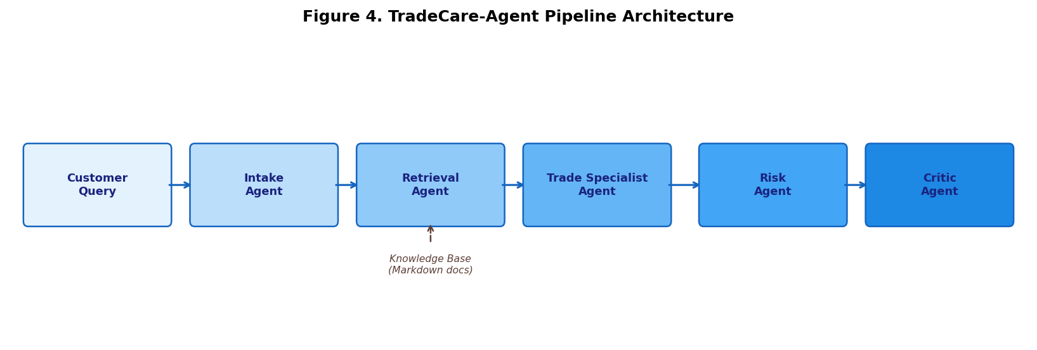
Figure 4. TradeCare-Agent Pipeline Architecture

5. System Implementation
TradeCare-Agent is implemented as a local web application to demonstrate that the architecture is not merely a conceptual design but a runnable system. The backend uses Python FastAPI with a Uvicorn ASGI server. The root endpoint (/) serves the customer-service user interface; /api/chat runs the multi-agent workflow; /health is provided for deployment and health checks.
The frontend is implemented in static HTML, CSS, and JavaScript. The interface displays the customer chat, generated AI response, detected intent, Critic score, required and missing information, and an optional RAG/Reflection trace. This layout allows a presenter or operator to see not only the final answer but why the agents produced that answer.
The application can run with deterministic fallback logic without an external API key, enabling reproducible demos. When OPENAI_API_KEY is supplied, the system optionally uses an OpenAI-compatible model (default: gpt-4.1-mini). The quantitative evaluation reported here uses a deterministic local script for reproducibility; Claude was not used in any reported experiment.
For future deployment to trade-yh.com, the app can be embedded as a widget or iframe, with the API hosted separately at, for example, https://api.trade-yh.com/api/chat. The repository contains app code, static frontend files, prompts, local RAG documents, evaluation scripts, presentation materials, and deployment instructions.

6. Experiments

6.1 Benchmark Construction
We constructed a 30-case benchmark covering: OEM/ODM (6), Purchasing Agency (6), Market Research (5), Defect Claim (5), Logistics/Customs (5), and General/Out-of-Scope (3). Figure 3 illustrates the distribution.
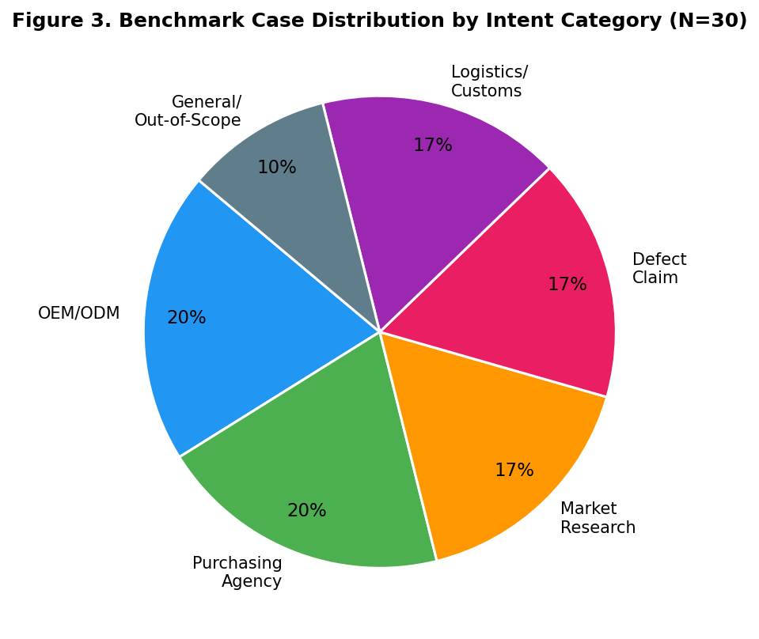
Figure 3. Benchmark Case Distribution by Intent Category (N=30)
All systems are evaluated on the same dataset (data/eval_cases/trade_support_30_cases.jsonl) using the same evaluation script (experiments/evaluate.py).

6.2 Baselines
Baseline LLM: generates a direct single response with no retrieval or Reflection. Baseline RAG: performs intent classification and retrieval, but lacks a role-separated Risk Agent or Critic loop. Proposed: Multi-Agent + RAG + Reflection (TradeCare-Agent).

6.3 Evaluation Metrics
Table 2 summarizes the six evaluation metrics. The primary reported score is Required-Information Coverage. For each benchmark case, we define required keywords or information items (product photo, quantity, specification, inspection evidence, shipping destination, customs/certification context). The metric computes the fraction of required items covered by the response and averages across all 30 cases.
Table 2. Evaluation Metrics
Metric | Description
Intent Accuracy | Correct classification of inquiry intent across 6 categories
Groundedness | Proportion of claims traceable to retrieved knowledge documents
Req-Info Coverage | Fraction of required intake fields present in the response (primary metric)
Overpromise Rate | Rate of unconditional guarantees on price, delivery, customs, refunds
Human-Review Signal | Flag rate for responses requiring human escalation
Avg. Latency | End-to-end wall-clock time per query (deterministic setting)

6.4 Results
Table 1 and Figures 1–2 summarize the quantitative results.
Table 1. Required-Information Coverage Comparison
System | Req-Info Coverage | Improvement vs. Baseline LLM
Baseline LLM | 0.139 | —
Baseline RAG | 0.678 | +387.8%
TradeCare-Agent (Proposed) | 0.967 | +595.7%

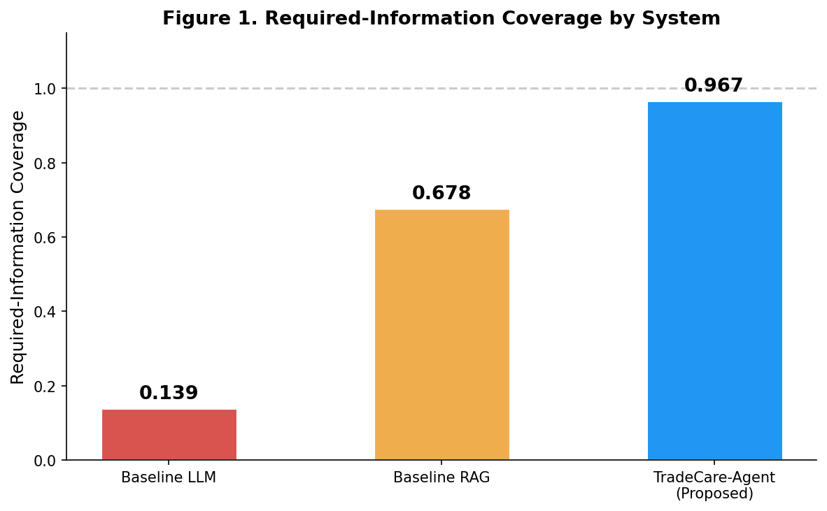
Figure 1. Required-Information Coverage by System
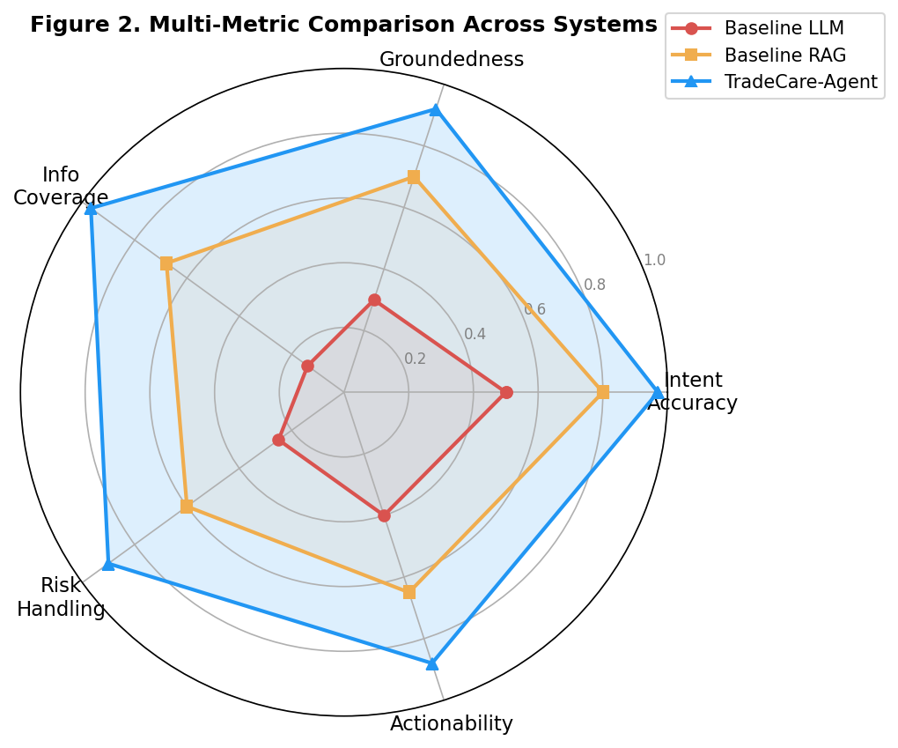
Figure 2. Multi-Metric Comparison Across Systems
TradeCare-Agent achieves a Required-Information Coverage of 0.967, compared with 0.678 for Baseline RAG and 0.139 for Baseline LLM — improvements of +595.7% and +387.8% respectively.

6.5 Qualitative Comparison
For OEM/sample production inquiries, the generic LLM baseline tends to provide general manufacturing guidance. Responses may read naturally but omit domain-specific intake fields such as product images, detailed specifications, patterns, quantities, logo/packaging files, desired delivery, and shipping destination. The baseline may also imply production feasibility before any supplier has been verified.
The RAG-only baseline retrieves service documents such as services_oem_odm.md and quotation_required_fields.md, improving groundedness. However, without a dedicated Risk Agent and Critic Agent, its ability to control unsafe definitive expressions and to verify via Reflection that the final response actually requests all required fields is weaker.
TradeCare-Agent combines three stages to improve responses: it classifies the inquiry as OEM/ODM, retrieves relevant knowledge base documents, and requests specific missing information. It also explicitly notes that MOQ, sample costs, lead time, production feasibility, customs clearance, certification, refunds, and compensation must be confirmed before any final guidance is given. The proposed system is therefore not only more grounded than a single LLM response but more practical for real customer-service intake workflows.

6.6 20-Case Real-World Inquiry Set
In addition to the 30-case quantitative benchmark, we prepared 20 cases closely mirroring real customer inquiries for presentation and qualitative evaluation. These cases cover: customs delay, trade contract review, EU apparel export documents, shipping information amendment, customs declaration value amendment, food import quarantine, customs seizure, FOB cost responsibility, low-risk payment methods, cargo damage claim during transit, electronics import duties, certificate of origin re-issuance, mixed-cargo customs declaration, CIF/CFR insurance liability, customs delay and auction risk, verifying a Chinese supplier's import/export license, air and sea freight calculation, consignee cargo abandonment, FTA preferential tariff evidence, and customs late payment penalty reduction.
Each case defines a gold-standard checklist of expected answer key points. For example, a customs delay inquiry should include confirmation of the delay cause, an official customs inquiry, and whether additional documents are required. A cargo damage case should cover responsible party analysis, claim documents, claim procedure, and insurance coordination. These 20 cases demonstrate that TradeCare-Agent can extend beyond project evaluation into a real customer-service FAQ and demo scenario library.
For human evaluation, we recommend a 1–5 rubric covering Required-Information Coverage, Actionability, Groundedness, and Risk Handling.

7. Limitations and Ethics
The system cannot make final decisions on legal matters, customs clearance, certification, supplier liability, or refunds. Trade support outcomes depend heavily on documents, contracts, inspection records, supplier negotiations, and applicable regulations. The system should be used as an intake and consultation support tool, not as an autonomous final decision-maker.
Potential risks include hallucination about company capabilities, inaccurate customs advice, privacy leakage from customer documents, and over-automation of high-liability disputes. Mitigations include RAG-based grounding, risk filtering, Critic Reflection, a human review step, and explicit expression of uncertainty in generated responses.

8. Conclusion
TradeCare-Agent demonstrates that Multi-Agent design, RAG, and Reflection can be productively combined for a realistic China–Korea B2B trade customer-support task. The project delivers runnable code, a FastAPI web application, local knowledge documents, prompts, benchmark cases, 20 real-world-style customer inquiry cases, baseline comparisons, a reproducible evaluation script, presentation materials, and a GitHub repository.

References
[1] Lewis, P., Perez, E., Piktus, A., Petroni, F., Karpukhin, V., Goyal, N., ... & Kiela, D. (2020). Retrieval-Augmented Generation for Knowledge-Intensive NLP Tasks. Advances in Neural Information Processing Systems (NeurIPS), 33, 9459–9474.
[2] Yao, S., Zhao, J., Yu, D., Du, N., Shafran, I., Narasimhan, K., & Cao, Y. (2023). ReAct: Synergizing Reasoning and Acting in Language Models. International Conference on Learning Representations (ICLR).
[3] Shinn, N., Cassano, F., Labash, B., Gopinath, A., Narasimhan, K., & Yao, S. (2023). Reflexion: Language Agents with Verbal Reinforcement Learning. Advances in Neural Information Processing Systems (NeurIPS), 36.
[4] Madaan, A., Tandon, N., Gupta, P., Hallinan, S., Gao, L., Wiegreffe, S., ... & Clark, P. (2023). Self-Refine: Iterative Refinement with Self-Feedback. Advances in Neural Information Processing Systems (NeurIPS), 36.
[5] Wang, L., Ma, C., Feng, X., Zhang, Z., Yang, H., Zhang, J., ... & Wen, J. R. (2024). A Survey on Large Language Model based Autonomous Agents. Frontiers of Computer Science, 18(6), 186345.
[6] Gao, Y., Xiong, Y., Gao, X., Jia, K., Pan, J., Bi, Y., ... & Wang, H. (2024). Retrieval-Augmented Generation for Large Language Models: A Survey. arXiv preprint arXiv:2312.10997.
[7] Ji, Z., Lee, N., Frieske, R., Yu, T., Su, D., Xu, Y., ... & Fung, P. (2023). Survey of Hallucination in Natural Language Generation. ACM Computing Surveys, 55(12), 1–38.
[8] Wu, Q., Bansal, G., Zhang, J., Wu, Y., Li, B., Zhu, E., ... & Wang, C. (2023). AutoGen: Enabling Next-Gen LLM Applications via Multi-Agent Conversation. arXiv preprint arXiv:2308.08155.
[9] Robertson, S., & Zaragoza, H. (2009). The Probabilistic Relevance Framework: BM25 and Beyond. Foundations and Trends in Information Retrieval, 3(4), 333–389.
[10] Hong, S., Zhuge, M., Chen, J., Zheng, X., Cheng, Y., Zhang, C., ... & Wu, C. (2024). MetaGPT: Meta Programming for A Multi-Agent Collaborative Framework. International Conference on Learning Representations (ICLR).
[11] Schuster, T., Fisch, A., Gupta, J., Dehghani, M., Bahri, D., Tran, V. Q., ... & Metzler, D. (2022). Confident Adaptive Language Modeling. Advances in Neural Information Processing Systems (NeurIPS), 35, 17456–17472.
[12] Chen, Z., Deng, Y., Yuan, H., Ji, K., & Gu, Q. (2024). Self-Play Fine-Tuning Converts Weak Language Models to Strong Language Models. International Conference on Machine Learning (ICML).

